1. INTRODUCTION

In 4th year in computer engineering department at Emu, we have Area electives courses. Theses are a list of courses where you have to pick one. For this semester, one of them CMSE425 IMAGE PROCESSING. In general, the course is about how images are processed. To practice what we are learning, we have Labs. This is the aim of this report, it is based on Lab 2.

1. Task Given

We were given 4 images, and using Matlab, we were asked to permed certains tasks. To avoid repeating the questions since it is in the lab sheet, we will proceed to the solution and result of the lab.

1. Lab Solution and Result

E1.

a)

i)Image negative on figure 1

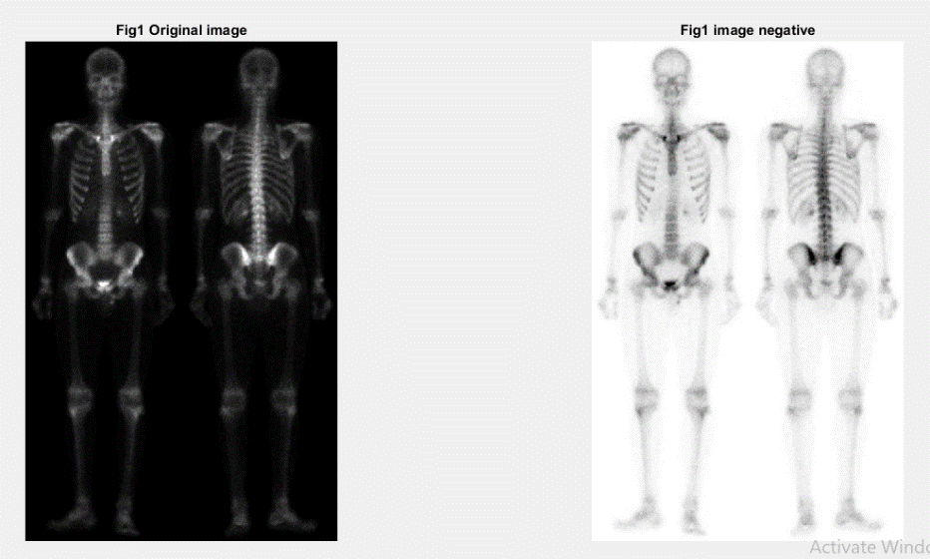

Here we can see that the the background became white.

Here is the code

im1=imread('Fig1.tif');

% image negative

im2= intrans(im1,'neg');

figure,

subplot (1,2,1), imshow(im1), title ('Fig1 Original image');

subplot (1,2,2), imshow(im2), title ('Fig1 image negative');

ii)Log Transformation

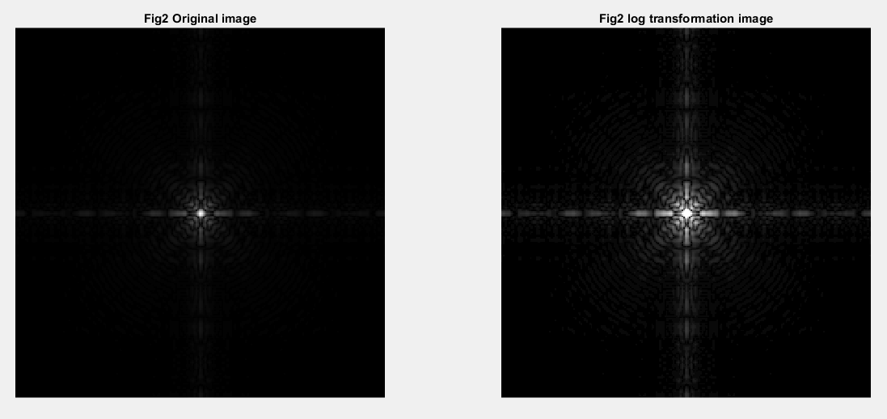

Here we can see that the light in the middle in the original picture is now distributed around the light.

Here is the code

im1=imread('Fig2.tif');

% Log transformation

im2= intrans(im1,'log',3);

figure,

subplot (1,2,1), imshow(im1), title ('Fig2 Original image');

subplot (1,2,2), imshow(im2), title ('Fig2 log transformation image');

iii)Gamma transformation

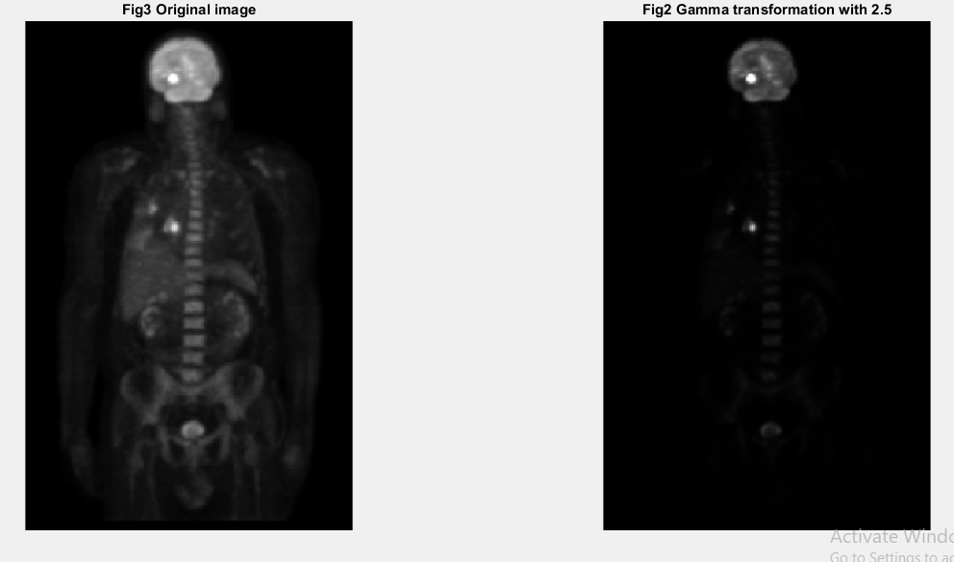

In this picture we can see that when we change the value GAM of the function, the intensity level of the body in the pictures changes as well.

Here is the code

im1=imread('Fig3.tif');

% Gamma transformation

im2= intrans(im1,'gamma',2.5);

figure,

subplot (1,2,1), imshow(im1), title ('Fig3 Original image');

subplot (1,2,2), imshow(im2), title ('Fig2 Gamma transformation with 2.5');

iv) Contrast Stretching

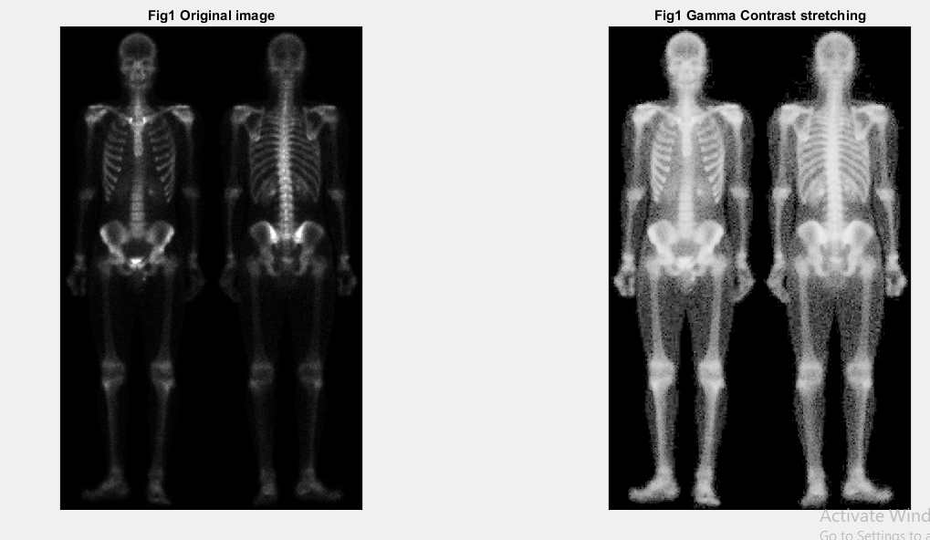

Here we can see that with contrast stretching, the bones are more visible.

Here is the code

im1=imread('Fig1.tif');

% Contrast stretching

im2=intrans(im1,'stretch',mean2(im2double(im1)), 0.9);

figure,

subplot (1,2,1), imshow(im1), title ('Fig1 Original image');

subplot (1,2,2), imshow(im2), title ('Fig1 Gamma Contrast stretching');

b)

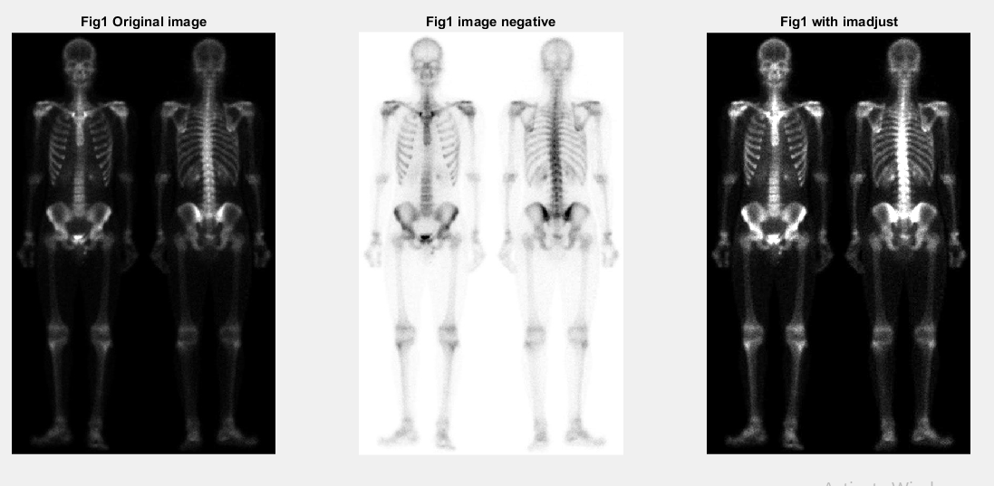

When we compare the negative function and imadjust, we see that the negative function changes the background whereas the imadjust function does not change that background. Therefore, the squeleton is more visible now.

Here is the code

im1=imread('Fig1.tif');

% image negative and imadjust

im2= intrans(im1,'neg');

im3=imadjust(im1);

figure,

subplot (1,3,1), imshow(im1), title ('Fig1 Original image');

subplot (1,3,2), imshow(im2), title ('Fig1 image negative');

subplot (1,3,3), imshow(im3), title ('Fig1 with imadjust');

E2)

a)

For this question, I would like to mention that the function bar was giving this error: “Caught exception while computing adjustment”. Therefore, I could not perform the “bar” function.

For the code, it is the same for all four tasks. The only difference is the name of the picture.

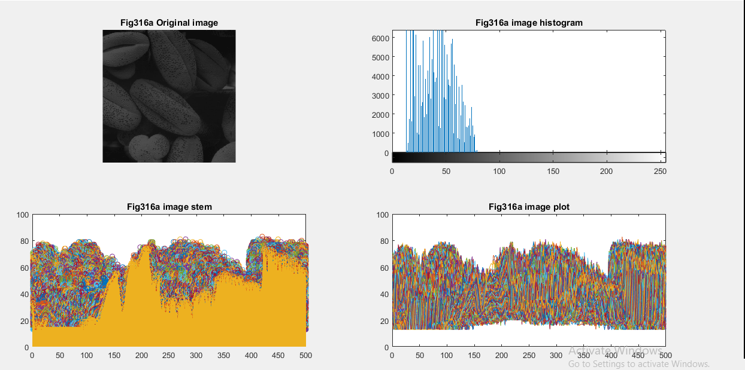

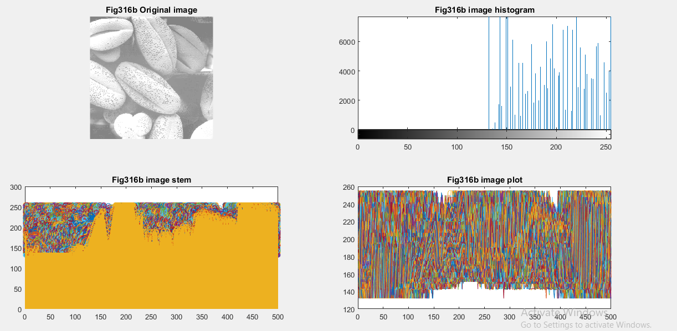

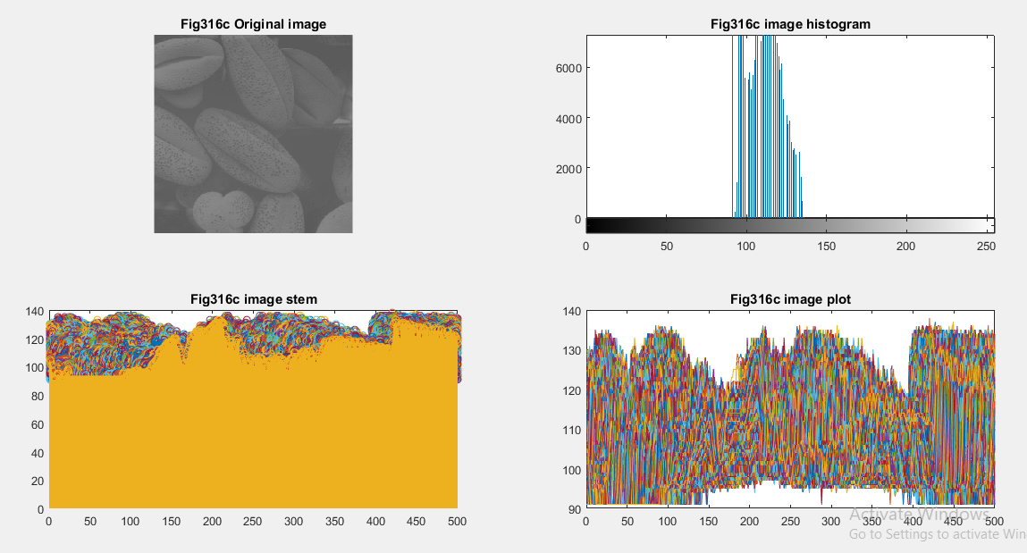

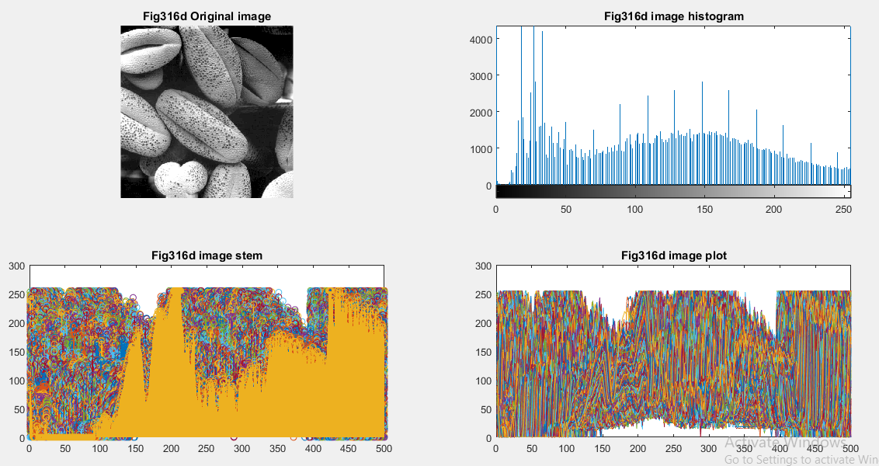

%Applying imhist,bar,stem,plot function

im1=imread('Fig316d.tif');

figure,

subplot (2,2,1), imshow(im1), title ('Fig316d Original image');

subplot (2,2,2), imhist(im1), title ('Fig316d image histogram');

% subplot (2,3,3), bar(im1), title ('Fig316d image bar');

subplot (2,2,3), stem(im1), title ('Fig316d image stem');

subplot (2,2,4), plot(im1), title ('Fig316d image plot');

b)Image Histogram comparison of 4 pictures before and after equalization

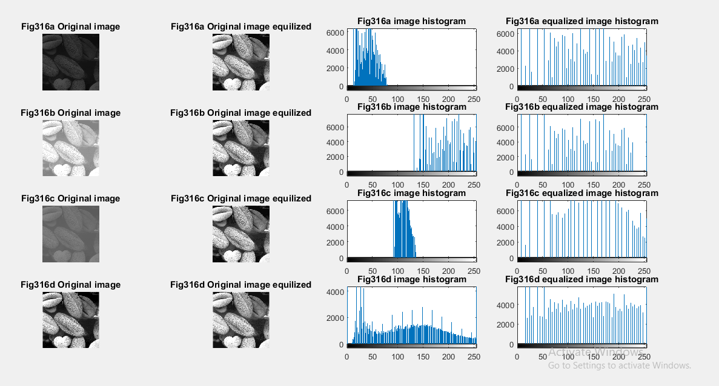

By using image equalization method, the pictures become more clearer or bright and the histograms become distributed compare to the original picture.

Here is the code.

%image histogram before and after equalization

im1=imread('Fig316a.tif');

im2=imread('Fig316b.tif');

im3=imread('Fig316c.tif');

im4=imread('Fig316d.tif');

im5=histeq(im1);

im6=histeq(im2);

im7=histeq(im3);

im8=histeq(im4);

figure,

subplot (4,4,1), imshow(im1), title ('Fig316a Original image');

subplot (4,4,2), imshow(im5), title ('Fig316a Original image equilized');

subplot (4,4,3), imhist(im1), title ('Fig316a image histogram');

subplot (4,4,4), imhist(im5), title ('Fig316a equalized image histogram');

subplot (4,4,5), imshow(im2), title ('Fig316b Original image');

subplot (4,4,6), imshow(im6), title ('Fig316b Original image equilized');

subplot (4,4,7), imhist(im2), title ('Fig316b image histogram');

subplot (4,4,8), imhist(im6), title ('Fig316b equalized image histogram');

subplot (4,4,9), imshow(im3), title ('Fig316c Original image');

subplot (4,4,10), imshow(im7), title ('Fig316c Original image equilized');

subplot (4,4,11), imhist(im3), title ('Fig316c image histogram');

subplot (4,4,12), imhist(im7), title ('Fig316c equalized image histogram');

subplot (4,4,13), imshow(im4), title ('Fig316d Original image');

subplot (4,4,14), imshow(im8), title ('Fig316d Original image equilized');

subplot (4,4,15), imhist(im4), title ('Fig316d image histogram');

subplot (4,4,16), imhist(im8), title ('Fig316d equalized image histogram');